***Complex Number***

**Introduction:** Complex analysis (traditionally known as the theory of functions of a complex variable) is the study of [complex numbers](http://mathworld.wolfram.com/ComplexNumber.html) together with their [derivatives](http://mathworld.wolfram.com/Derivative.html), manipulation, and other properties and investigates function of complex numbers. Complex analysis is an extremely powerful tool with an unexpectedly large number of practical applications to the solution of physical problems. [Contour integration](http://mathworld.wolfram.com/ContourIntegration.html), for example, provides a method of computing difficult [integrals](http://mathworld.wolfram.com/Integral.html) by investigating the singularities of the function in regions of the [complex plane](http://mathworld.wolfram.com/ComplexPlane.html) near and between the limits of integration.

**Why complex number system is introduced?**

Mathematics has its own language in which Alphabets are numbers, so number system is so important in mathematics**.** The prince of mathematics Gauss said that every polynomial has at least one root and that Polynomial has maximum roots exactly equal to its order or degree. Above statement is called the fundamental theorem of Algebra. When we consider the polynomial equation like asthat implies but which is not possible in the real field because square of any real number is non-negative so real field fails to give the solution of this polynomial equation. But fundamental theorem of Algebra tells it has maximum two roots. To permit the solution of the equation  and similar types, the set of complex numbers is introduced. Therefore, complex number system includes real number system as a subset, so complex number system is the extended form of real number system that solved the above considered problem. By considering the problem provides two complex roots that covered the fundamental theorem of Algebra stated by great mathematician Gauss .It is notable that the mathematician Euler first use the symbol for imaginary unit and its geometrical meaning in the complex plane is the point . Solution of the above arises problem is as follows:







Finally, we conclude that the roots of the aroused problem are  and.

**Complex variable:** A complex variable is a linear combination of two real variables *x* and *y* with the special sign and it is defined as,

 where and.

Alternatively, the symbol, which stands for any of a set of complex numbers, is called a complex variable. Geometrically, a complex variable represents a general point in the complex plane/Argand Plane/Argand diagram/Gaussian Plane.

**Complex number:** Any number of the form , whereand, is called a complex number and it is denoted by.

i.e. 

In complex number *z*, *x* is the real part of *z* denoted by the symbol  and *y* is the imaginary part of *z* denoted by the symbol and also  is called imaginary unit. Geometrically, a complex number represents a unique point in the complex plane/Argand Plane/Argand diagram/Gaussian Plane. Also geometrically,  is the projection of on to the *x* axis, and  is the projection of *z* on to the *y* axis.

**O**

**X’**

**Y**

**Y’**

**X**



**Properties of complex numbers:** If , ,  belong to the set  of complex numbers, the following properties hold.

1.  Closure law
2.  Commutative law of addition
3.  Associative law of addition
4.  Commutative law of multiplication
5.  Associative law of multiplication
6.  Distributive law
7.   is called the identity with respect to addition, 1 is called the identity with respect to multiplication.
8. For any complex number  there is a unique number in  such that ; is called the inverse of  with respect to addition and is denoted by .
9. For any there is a unique number in  such that ; is called the inverse of with respect to multiplication and is denoted by .

In general, any set which satisfy above conditions is called a field.

**Conjugate of complex number:** Theconjugate of a complex number  is obtained by changing the sign of *y* and is denoted by the symbol  i.e. .Geometrically, the conjugate of a complex number represents the reflection or image of the complex number *z* about the real axis *x*.

P( x , y)

**X’**

**Y**

**Y’**

**X**

**O**

P’( x, -y)

**Cartesian form/Rectangular form:** The form of the complex number , where is called Cartesian form.

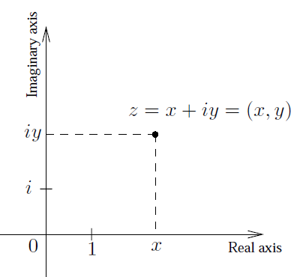

**Polar Form:** The Cartesian form of a complex number is 

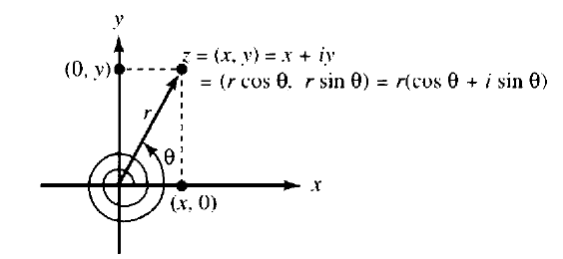From the relation of Cartesian and polar system, we have

 and .

Now,





 (1)

 (2)

The form of equation (1) is called the polar form and the form of equation (2) is called the exponential form.

**Modulus/Absolute value:** The modulus of a complex numberis a nonnegative real number denoted by  and is defined by the equation.

The number |z| is the distance between the origin and the point (*x*, *y*) in Argand Plane or Gaussian plane. The only complex number with modulus zero is the number 0. The numbers | Re(z) | , | lm(z) |, and | z | are the lengths of the sides of the right triangle OPQ, which is shown in the following figure

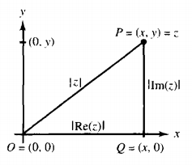

**Properties of moduli:** If , , , ,  are complex numbers, the following properties hold.

1. 
2. 
3. 
4. .

**Argument or Amplitude of a complex number:** Consider the complex number is, . We know that the relations between the Cartesian coordinates (*x*, *y*) and Polar coordinates  are,

 and 

We can write from above relations,

 

This quantity is called the argument or amplitude of the complex number *z* . It is denoted by arg(z )or amp(z). A complex number has infinite many possible arguments. But in the range  every complex number has unique argument called principal argument of that number and is denoted by **Argz.**









Argument = arg(z)

Theorem on argument:

* 
* 

**Euler’s Formula:** The relation  is called Euler’s formula.

**Deduction:** We know that the infinite series of trigonometric functions are



and 

We have



Replacing  by in the above equation we get,







which is known as **Euler’s Formula . (Deduced)**

**De Movire’s theorem:** For all rational values of *n* the De Movire’s theorem is defined as,

.

**Deduction:** If and , then









In general,

 (1)

If , then (1) becomes



which is called De Moivre’s theorem.

**Roots of a complex numbers:**

A number  is called an root of a complex number *z* if and it can be written as



By assuming we get,











When  then it represents n-th root of unity,

.



If we let , the n roots are 

Geometrically they represent the *n* vertices of a regular polygon of *n* sides inscribed in a circle of radius one with C centre at origin. This circle has the equation  and is often called the unit circle.

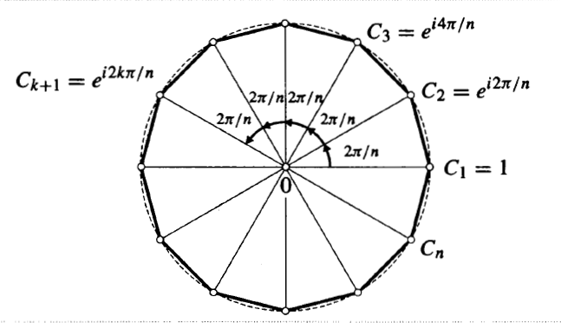

**Complex Polynomial and Equation:** Any expression of the form



is called a complex polynomial of degree , where .

If then it is called a complex equation of degree .

If  are the roots of the above equation then



It is called the factor form of the above polynomial equation.

**Complex conjugate coordinates:** A point in the complex plane can be located by rectangular coordinates  or polar coordinates . Many other possibilities exists. One such possibility uses the fact that  and  where . The coordinates  which locate a point are called complex conjugate coordinates or briefly conjugate coordinates of the point.

**Dot and Cross Product of complex numbers:** Let  and  be two complex numbers (vectors). The dot or scalar product of  and  is defined by



where  is the angle between  and  which lies between  and .

Again, the cross product of  and  is defined by



If  and  are non-zero, then

1. A necessary and sufficient condition that  and  be perpendicular is that .
2. A necessary and sufficient condition that  and  be parallel is that .
3. The magnitude of the projection of  is .
4. The area of a parallelogram having sides  and  is .

**Problems**

**Problem-01:** Find real numbers *x* and *y* such that ..

**Solution:** Given that,



Comparing the real parts and imaginary parts of the equation of complex numbers we get,





Solving the above equations we get the values  and . **(As desired)**

**Problem-02:** Convert the complex number in its Cartesian/ Rectangular Form.

**Solution:** Given that,

 [Using Euler’s Formula]







This is the required rectangular form or Cartesian form, where and . **(As desired)**

**Problem-03:** Find the modulus and argument of the complex number **.**

**Solution:** Given Complex number is,





















where .

The modulus of the given complex number is,



And the argument of the given complex number is,



This is the principal argument of the complex number.

The general argument of the complex is



. where 

**Problem-04:** Find the modulus and argument of the complex number **.**

**Solution:** Given Complex number is,



















where .

The modulus of the given complex number is,



And the argument of the given complex number is,



This is the principal argument of the complex number.

The general argument of the complex is



. where 

**Problem-05:** Find the modulus and argument of the complex number **.**

**Solution:** Given Complex number is,

















where .

The modulus of the given complex number is,



And the argument of the given complex number is,



This is the principal argument of the complex number.

The general argument of the complex is



. where 

**Problem-06:** Find the modulus and argument of the complex number **.**

**Solution:** Given Complex number is,















where .

The modulus of the given complex number is,



And the argument of the given complex number is,



This is the principal argument of the complex number.

The general argument of the complex is



. where 

**Problem-07:** Find the modulus and argument of the complex number **.**

**Solution:** Given complex number is,





 and 

The modulus of the given number is,



















And argument of the given number is,















This is the principal argument of the complex number.

The general argument of the complex number is,



. where 

**Problem-08:** Find the modulus and argument of the complex number **.**

**Solution:** Given complex number is,















where and 

The modulus of the given number is,











And argument of the given number is,









This is the principal argument of the complex number.

The general argument of the complex number is,



. where 

**Problem-09:** Express each of the following complex numbers in polar form and exponential form.

1. **(b)**

**Solution: (a):** Given that,

Here,

Modulus or absolute value is,

Amplitude or Argument is,

The polar form is 

The exponential form is **Ans.**

**(b):** Given that,

Modulus or absolute value is,

Amplitude or Argument is,

The polar form is 

The exponential form is **Ans.**

**Problem-10:** Express each of the followings to the form:

**(a).**  **(b).**  **(c).** 

**(d).** 

**Solution: (a).** Given that,







 [Multiplying numerator and denominator by ]











where  **(As desired).**

**(b).** Given that, 













 

Let  so  and 

 and 

 

 

 

 

The exponential form of  is,





Now, from (1) we have,





















where  **(As desired).**

**(b).** Given that, 















where  **(As desired).**

**(d). Given that,** 





















where  **(As desired).**

**Problem-11: Prove the identities:**

**(a) **

**(b) **

**Solution:** By De Movire’s Formula we can write,













(a). Comparing Real terms on both sides, we get















(b). Comparing imaginary terms on both sides, we get











 (**Proved)**

**Problem-12: Prove the identities:**

**(a) **

**(b) **

**Solution:** (a) we have, 











 **(Proved)**

(b). we have, 











 **(Proved)**

**Problem-13:** Find the square roots of the following complex numbers:

**(a) **

**(b) **

**(c) **

**Solution:** **(a)** Let the square roots of the given complex number are



where and  are real numbers.







Separating real and imaginary parts, we get





From (2), we get



From (1) and (3), we get













Since is real so  is not acceptable.





when then from (3), we have





when then from (3), we have





or, 

Thus, the square roots of the given complex number are

 **(Ans)**

**(b)** Let the square roots of the given complex number are



where and  are real numbers.







Separating real and imaginary parts, we get





From (2), we get



From (1) and (3), we get













Since is real so  is not acceptable.





when then from (3), we have





when then from (3), we have





or, 

Thus, the square roots of the given complex number are

 **(Ans)**

**(c)** Let the square roots of the given complex number are



where and  are real numbers.







Separating real and imaginary parts, we get





From (2), we get



From (1) and (3), we get













Since is real so  is not acceptable.





when then from (3), we have





when then from (3), we have





or, 

Thus, the square roots of the given complex number are

 **(Ans)**

**Problem-14:** Find (a) fifth roots of unity (), (b) seventh roots of , (c) fourth roots of .

**Solution: (a)** Let is the fifth roots of unity.

So, 









Thus, the required roots are

, , , , . **(Ans)**

**(b)** Let is the seventh roots of .

So, 









Thus, the required roots are

, , , , , , . **(Ans)**

**(c)** Let is the fourth roots of .

So, 









Thus, the required roots are

, , , . **(Ans)**

**Problem-15:** Find each of the indicated roots of the following:

(a)  , **(b)**  , **(c)** , **(d)** , **(e)** , **(f)** , (g) 

**Solution:** **(a)** Let  

The polar form of this complex number is











Thus, the required roots are

, , . **(Ans)**

**(b)** Let  

The polar form of this complex number is











Thus, the required roots are

, , , . **(Ans)**

**(c)** Let  

The polar form of this complex number is











Thus, the required roots are

, . **(Ans)**

**(d)** Let  

The polar form of this complex number is











Thus, the required roots are

, , , , . **(Ans)**

**(e)** Let  

The polar form of this complex number is









Thus, the required roots are

, , , , , . **(Ans)**

**(f)** Let  

The polar form of this complex number is









Thus, the required roots are

, , . **(Ans)**

**(g)** Let  

The polar form of this complex number is











Thus, the required roots are

, , , . **(Ans)**

**Problem-16:** Solve the equations

1. .
2. .
3. .

**Solution**: (i). Given that,

Since it is a quadratic equation so its solutions are,

[ If then z = ]

and **Ans.**

**(ii).** Given that, … … (1)

The integer factors of and  are respectively and . The possible rational solutions are .

Let,

By trial solution we get, ;

Therefore, or is a factor.

Now,

Again let

By trial solution,

Therefore, or is a factor of .

Equation (1) becomes,

Hence, and .

Thus the solutions are . **Ans.**

**(iii).** Given that,

6

Therefore, the roots are: and **Ans.**

**Problem-17: Solve the following equations.**

(a)  , **(b)**  , **(c)** 

**Solution: (a)** Given that







 **(Ans)**

**(b)** Given that







 **(Ans)**

**(c)** Given that



The polar form of this complex number is









 **(Ans)**

**Problem-18:** Find all solutions of the following equations:

1. 
2. 
3. 

**Solution: (a)** Given that  (1)

We know that, 



From (1), we can write





















 **(Ans)**

**(b)** Given that  (1)

We know that, 



From (1), we can write















 **(Ans)**

**(c)** Given that  (1)

We know that, 



From (1), we can write















 **(Ans)**.

**Problem-19:** For any complex number  prove the followings:

1. 
2. 
3. 
4. 
5. 
6. 

**Solution: (a)** Let . Then 

Now 





and 





Hence  **(Proved)**

**(b)** Let . Then 

Now 





Hence  **(Proved)**

**(c)** Let  and . Then  and .

Now 









Hence  **(Proved)**

**(d)** Let  and .



Now 















Hence  **(Proved)**

**(e)** we know that 





















Hence  **(Proved)**

**(f)** we know that 





















Hence  **(Proved)**

**Problem-20:** Describe geometrically the region of the followings:

1. 
2. 
3. 
4. 
5. 
6. 
7. 
8. 
9. 
10. 
11. 
12. 
13. 
14. 







**Solution: (a)** Given that

Let . The given expression reduces as,















Therefore, the region is the set of all points  such that That is, the set of all points lie in the left hand side of the straight line .









**(b)** Given that

Let . The given equation reduces as,













Therefore, the region is the set of all points  such that . That is, the set of all points lie on the real axis.

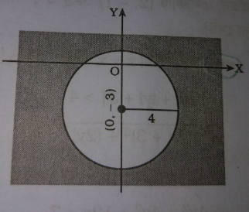**(c)** Given that

Let . The given expression reduces as,









Therefore, the region is the set of all external points of the circle , whose centre is and radius is .

**(d)** Given that

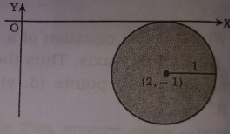Let . The given expression reduces as,









Therefore, the region is the set of all internal points including boundary points of the circle , whose centre is and radius is .

**(e)** Given that

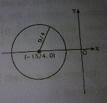Let . The given equation reduces as,

























Therefore, the region is the set of all boundary points of the circle , whose centre is and radius is .

**(f)** Given that

Let . The given expression reduces as,



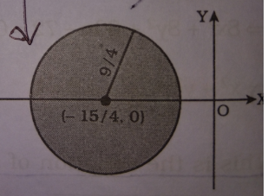





















Therefore, the region is the set of all internal points of the circle , whose centre is and radius is .

**(g)** Given that

Let . The given expression reduces as,









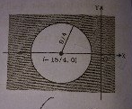















Therefore, the region is the set of all external points of the circle , whose centre is and radius is .

**(h)** Given that

Let . The given expression reduces as,

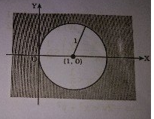 









Therefore, the region is the set of all external points of the circle , whose centre is and radius is .

**(i)** Given that

Let . The given expression reduces as,









Therefore, the region is the set of all common points of external points of the circle and internal points of the circle  including its boundary points.

**(j)** Given that

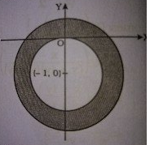Let . The given expression reduces as,









Therefore, the region is the set of all common points of external points of the circle and internal points of the circle  including its boundary points.

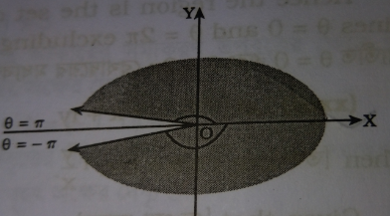**(k)** Given that



Therefore, the region is the set of all infinite points between the lines and .

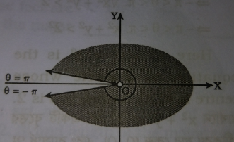**(l)** Given that



Therefore, the region is the set of all infinite points between the lines and excluding the origin.

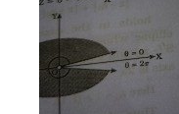

**(m)** Given that



Therefore, the region is the set of all infinite points between the lines and excluding the origin.

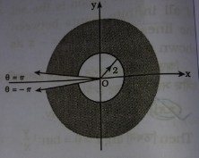**(n)** Given that



Therefore, the region is the set of all infinite common points among the lines , and external of the circle .

**Exercise:**

**Problem-01:** Express each of the following complex numbers in polar form.

(a). (b). (c). (d).

**Problem-02:** Express in A+iB form.

(a) (b)

**Problem-03:** Show that (a).

(b).

**Problem-04:** Show that (a).

(b).

**Problem-05:** Solve: (a).

(b). .

(c).

(d).